# ER diagram

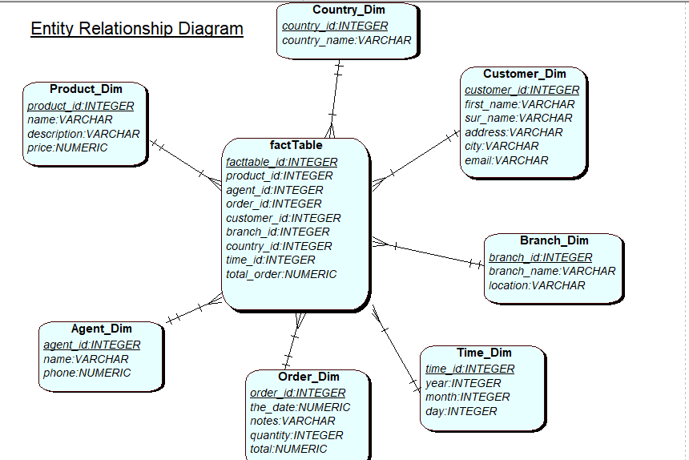

1. Number of orders made in UK first quarter of the year, in comparisons with last year?

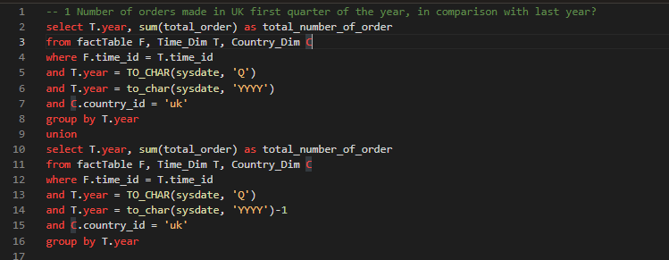

1. Who is best customer, in first quarter of this year?

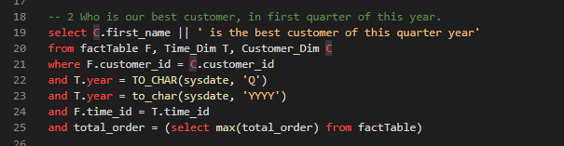

1. Total number of orders made in first quarter of the year, in comparison with last year for each branch

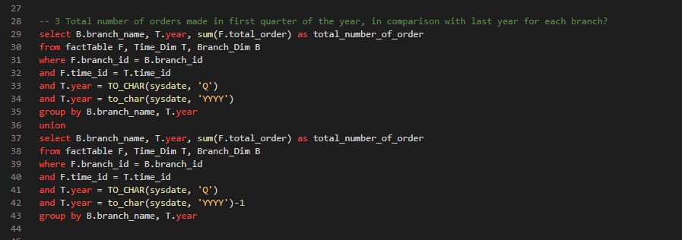

1. Who is best agent in the first quarter of this year?

